Myelination Implicated by WGCNA: Supplement for Grant

In order to better understand the neurological pathology of ArgI deficiency, we investigated the prefrontal cortex transcriptomes of P13, P14, and P15 ArgI knock-out, heterozygous, and treated knock-out (AAV-based gene therapy given on day 2 of life) mice using Affymetrix1 microarray technology (Affymetrix GeneChip® Mouse Genome 430 2.0 Array).

We used Weighted Gene Co-Expression Network Analysis (WGCNA)2 to analyze our gene expression data. WGCNA essentially takes a gene co-expression matrix as input and finds modules of co-expressed genes through hierarchical clustering. Our WGCNA-processed gene expression data revealed several dysregulated gene modules in the knock-out mice and highlighted trends in gene expression across phenotypes. One such dysregulated module, the ‘salmon’ module (each module is named with a color), was enriched with the ‘myelination’ gene ontology term (using Go-Elite3 gene ontology enrichment analysis, Z-score=4.43 and permuted p=0, 2000 permutations). The salmon module eigengene (the 1st principal component of the gene expression from genes in the module across samples) was down-regulated in knock-outs compared to controls, and an ANOVA test done with this salmon module eigengene also revealed significant down-regulation in knock-outs (ANOVA FDR adjusted p=0.03, knock-out Tukey’s post hoc test knock-out p=0.003). See Figure 1 for these measures and a plot of the genes in the salmon module, with ‘hub’ genes (genes that drive the expression of the whole module) plotted closest to the center.

We performed several tests to validate that myelination-related processes could be adversely effected in the Arg1 knock-out mouse. We used pSI4 to look for enrichment of cell-type specific gene markers in the salmon module (cell marker data obtained from Zhang et al.5). We observed a significant enrichment of myelinating oligodendrocyte gene markers in the salmon module (Bonferroni corrected p=0.001). Then, using Fisher’s exact test, we found that the salmon module was significantly enriched for differentially expressed genes (FDR adjusted p < 1e-76) between controls and knock-outs. The salmon module was also significantly enriched for genes that are up-regulated during development in CNS vasculature (FDR adjusted p =1.57e-04 ). These developmentally up-regulated genes were obtained from Daneman et al.6 Finally, upon inspection with DAPPLE7 to look for protein-protein interaction (PPI) enrichment in the salmon module, we saw a significant enrichment of PPIs (permuted p=0.05894) when inputting the top 300 hub genes into DAPPLE.

This salmon module is certainly dysregulated in its gene expression, and its enrichment for the myelination gene ontology term and myelinating oligodendrocyte cell markers point us towards myelination dysregulation specifically in the Arg1 knock-out mouse. The salmon module’s enrichment for differentially expressed genes, developmentally up-regulated CNS vasculature genes, and PPIs could detrimentally effect myelination in the Arg1 knock-out mouse.

In addition to our own data implicating dysregulated myelination in Arg1 deficiency, we see evidence in the literature for myelination defects in Arg1 deficiency and intellectual disability. Myelination depletion in Arg1 deficiency in a human case study has been identified previously by Segawa et al.8. Additionally, a recent Neuron paper9 examining Down’s syndrome model mice also observed myelination dysregulation in the transcriptome and in brain tissue. As Down’s syndrome is a form of intellectual disability, it is possible that the demyelination they see is related to intellectual disability in general. These previous studies along with our own dysregulated myelination findings in our gene expression data provide convincing evidence to investigate myelination in the Arg1 knock-out mouse.

FIGURE

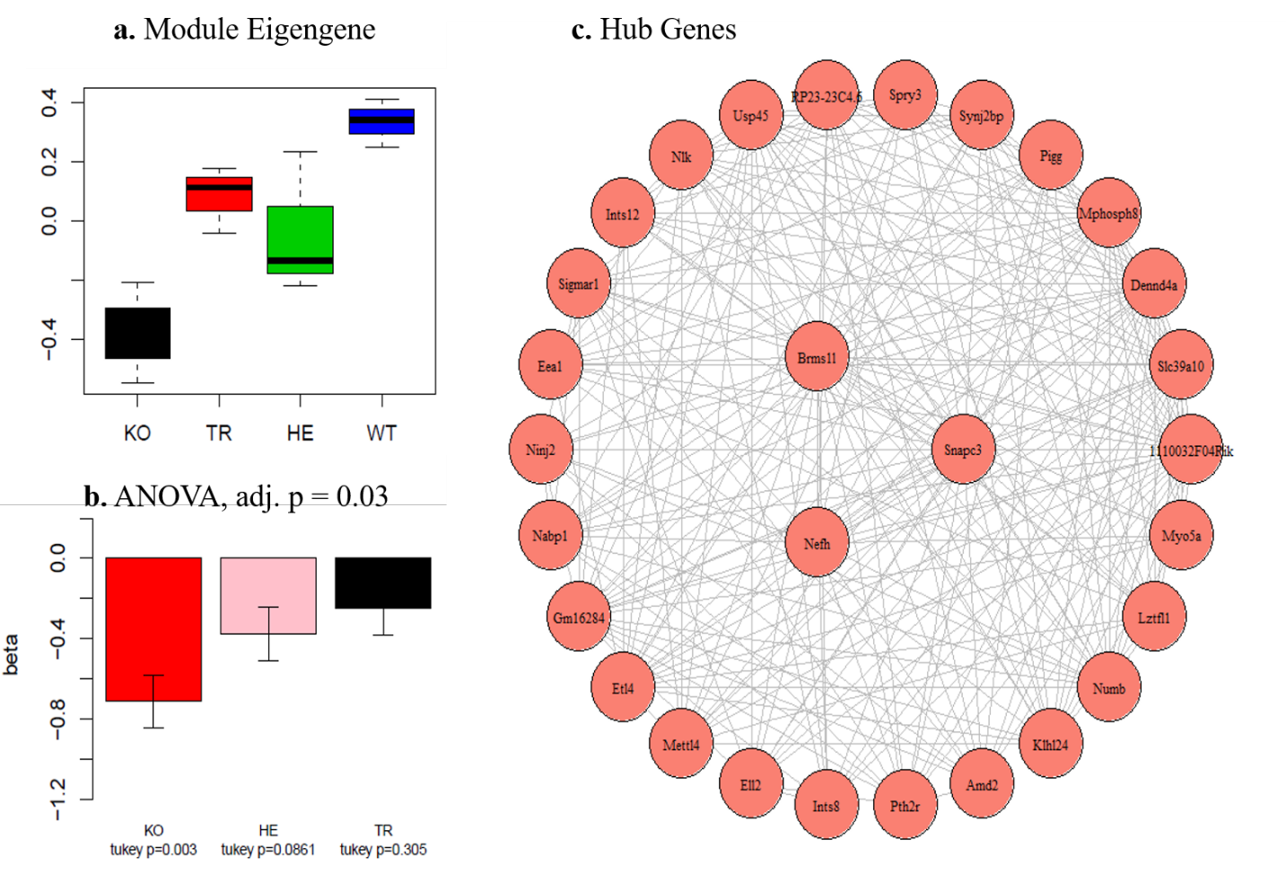

**Figure 1: Salmon Module. (a)** Shows the box plot of the module eigengene values for each condition (KO = knock-out, TR = treated knock-out, HE = heterozygote, WT=wild-type). **(b)** Shows the bar plot of the coefficients of a linear model predicting the module eigengene value from condition, where WT is the baseline. The ANOVA FDR adjusted p value and Tukey post hoc test p values are also depicted. **(c)** Shows the hub genes of the salmon module, where each edge represents significant connectivity between the two genes. Nefh, Brms11, and Snapc3 are the most correlated with the module eigengene. Whiskers extend to the range of the data in **(a)**, and standard error of the mean is shown in **(b)**.

REFERENCES

1: http://www.affymetrix.com/

2: Peter Langfelder, Steve Horvath (2012). Fast R Functions for Robust Correlations and Hierarchical Clustering. Journal of Statistical Software, 46(11), 1-17. URL <http://www.jstatsoft.org/v46/i11/>.

3: [GO-Elite: A Flexible Solution for Pathway and Ontology Over-Representation](http://bioinformatics.oxfordjournals.org/cgi/content/abstract/bts366). Alexander C. Zambon; Stan Gaj; Isaac Ho; Kristina Hanspers; Karen Vranizan; Chris T. Evelo; Bruce R. Conklin; Alexander R. Pico; Nathan Salomonis. Bioinformatics 2012; doi: 10.1093/bioinformatics/bts366

4: Xu, Xiaoxiao et al. “Cell Type-Specific Expression Analysis to Identify Putative Cellular Mechanisms for Neurogenetic Disorders.” *The Journal of Neuroscience*34.4 (2014): 1420–1431. *PMC*. Web. 11 May 2016.

5: Zhang, Ye et al. “An RNA-Sequencing Transcriptome and Splicing Database of Glia, Neurons, and Vascular Cells of the Cerebral Cortex.” *The Journal of Neuroscience* 34.36 (2014): 11929–11947. *PMC*. Web. 11 May 2016.

6: Daneman R, Zhou L, Agalliu D, Cahoy JD, Kaushal A, et al. (2010) The Mouse Blood-Brain Barrier Transcriptome: A New Resource for Understanding the Development and Function of Brain Endothelial Cells. PLoS ONE 5(10): e13741. doi: 10.1371/journal.pone.0013741

7: [Rossin EJ, Lage K, Raychaudhuri S, Xavier RJ, Tartar D, IIBDGC, Cotsapas C, Daly MJ.](http://www.plosgenetics.org/article/info%3Adoi%2F10.1371%2Fjournal.pgen.1001273) 2011 Proteins Encoded in Genomic Regions Associated with Immune-Mediated Disease Physically Interact and Suggest Underlying Biology. *PLoS Genetics* 7(1): e1001273 8:

8: Yoshie Segawa, Mayumi Matsufuji, Naoya Itokazu, Hidetsuna Utsunomiya, Yoriko Watanabe, Makoto Yoshino, Sachio Takashima, A long-term survival case of arginase deficiency with severe multicystic white matter and compound mutations, Brain and Development, Volume 33, Issue 1, January 2011, Pages 45-48, ISSN 0387-7604, <http://dx.doi.org/10.1016/j.braindev.2010.03.001>.

#### 9: Jose Luis Olmos-Serrano9, Hyo Jung Kang9, William A. Tyler9, John C. Silbereis9, Feng Cheng, Ying Zhu, Mihovil Pletikos, Lucija Jankovic-Rapan, Nathan P. Cramer, Zygmunt Galdzicki, Joseph Goodliffe, Alan Peters, Claire Sethares, Ivana Delalle, Jeffrey A. Golden, Tarik F. Haydarcorrespondenceemail, Nenad Sestan, Down Syndrome Developmental Brain Transcriptome Reveals Defective Oligodendrocyte Differentiation and Myelination, Neuron, Volume 89 , Issue 6 , 1208 – 1222, 16 March 2016